**Answers**

1: - Difference Between explode() and slpilt()?

Both are used to split a string into an array, but the difference is that split() uses pattern for splitting whereas explode() uses string. explode() is faster than split() because it doesn't match string based on regular expression. ... The explode() function splits the string by string

2: - Diference b/w mysqli_fetch_array(),mysqli_fetch_object(), and mysqli_fetch_row()?

Mysql_fetch_object returns the result from the database as objects while mysql_fetch_array returns result as an array. This will allow access to the data by the field names.

mysql_fetch_row() fetches one row of data from the result associated with the specified result identifier. **The row is returned as an array. Each result column is stored in an array offset, starting at offset 0.**

3: -Which Function is used to determines if the type of variable is FLOAt?

The is_float() function checks whether a variable is of type float or not. This function returns true (1) if the variable is of type float, otherwise it returns false.

4: - Name of Type Errors for PHP

* Parse Error (Syntax Error)
* Fatal Error
* Warning Error
* Notice Error

5: - Which is not introduced in PHP 7

NAMESPACES

6: - NOT VALID PHP COMPARISON OPERATOR?

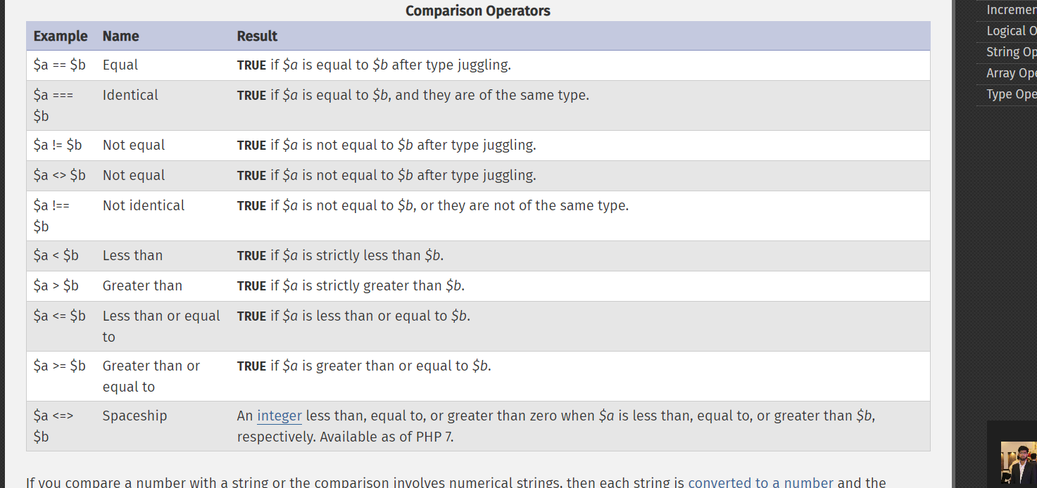

7: - Send a message to a socket regardless of whether it is connected or not. Which is used?

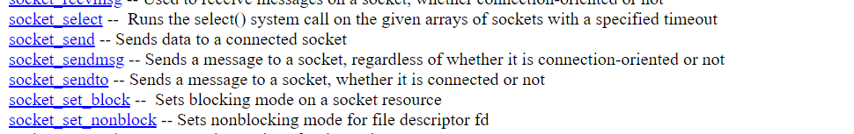

8: - Want to stablish the modify (And Access) date of file , Which is Used?

The filemtime() function in PHP is an inbuilt function which is used to return the last time of a specified file when its content was modified. The filemtime() function returns the last time the file was changed as a Unix Timestamp on success and False on failure

9: Want to determine if a cookie was privuosly set up , which is use?

setCOokie()